CS220: Database Systems
Class: BSCS-15D, BSAI – 2A
Date: 2 Februrary 2026
Time: 14:00 - 16:50

Instructor: Sara Tariq Sheikh
Lab engineer: Hamza Fyaz, Saood Sarwar
Submitted By: Noor Fatima
CMS ID: 559891
Task 1:
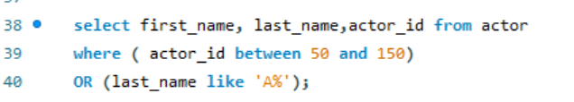
Output:
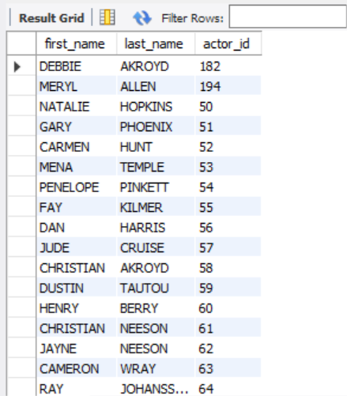
Task 2:
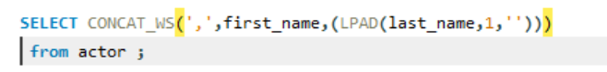
Output:
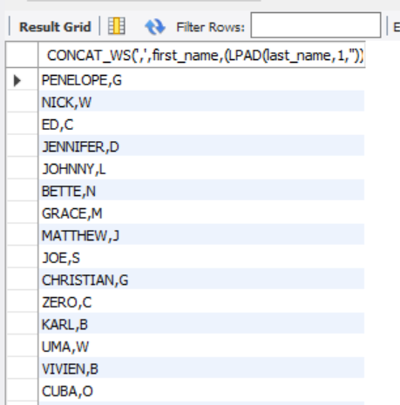
Task 3:
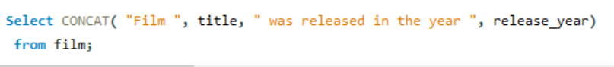
Output:
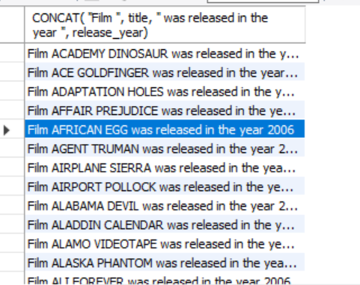
Task 4:
Output:
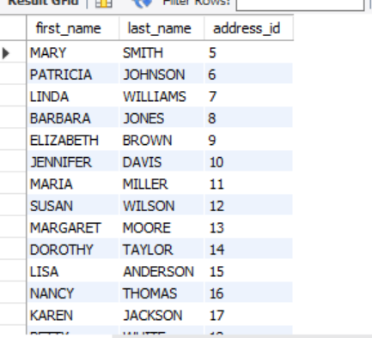
Task 5:
- First substring use was first and last intials of actors:
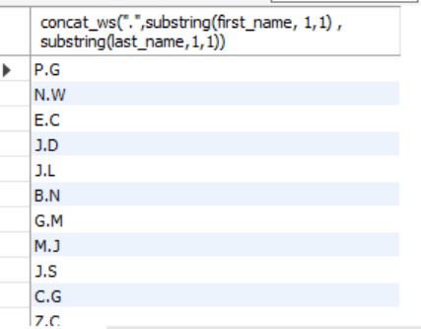
- Giving only starting usernames in email, removing the domain of emails.
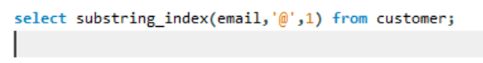
Output:
